SQL Project Report
Name : Harsha Vardhini V
Register Number : 212304909
Course: SQL / Naan Mudhalvan
College Name : St Anne’s Arts and Science College

Project Title: Retail Sales Database Analysis
Objective: To design a retail sales database and analyze sales performance, customer behavior, and product trends using SQL queries.

Database Design
Tables Created: customers, products, orders, order_items

Sample Data Inserted
Customers Table
customer_id | customer_name | City | state
1 | Arun | Chennai | Tamil Nadu
2 | Priya | Coimbatore | Tamil Nadu
3 | Rahul | Bangalore | Karnataka
4 | Sneha | Hyderabad | Telangana
5 | Vikram | Chennai | Tamil Nadu
Products Table
product_id | product_name | category | price
101 | Laptop | Electronics | 50000
102 | Mobile | Electronics | 20000
103 | Shoes | Fashion | 3000
104 | Watch | Accessories | 2500
105 | Headphones | Electronics | 1500

Query Results
1. Total Sales per Product and Category
product_name | Category | sales_amount
Headphones | Electronics | 3000
Laptop | Electronics | 50000
Mobile | Electronics | 40000
Shoes | Fashion | 9000
Watch | Accessories | 2500
2. Top 5 Customers by Purchase Value
customer_name | sales_amount
Arun | 50000
Priya | 40000
Rahul | 9000
Vikram | 3000
Sneha | 2500
3. Monthly Sales Trend
Month | sales_amount
1 | 90000
2 | 11500
3 | 3000
4. Average Order Value: 20900.0

Explanation
Tables are separated to avoid data duplication and maintain data integrity. Primary keys uniquely identify records, while foreign keys establish relationships between tables. SQL queries use JOIN, GROUP BY, and aggregate functions to analyze sales performance.

OUTPUT SCREENSHOTS
- CREATE TABLE statements
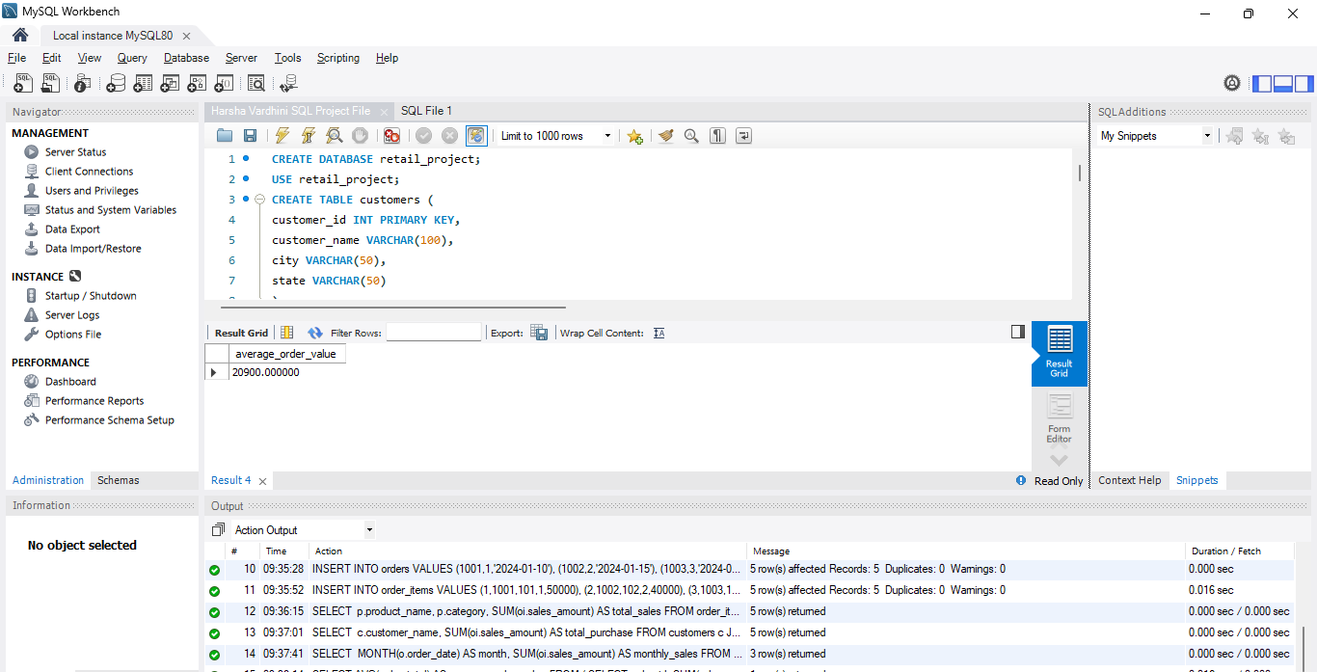
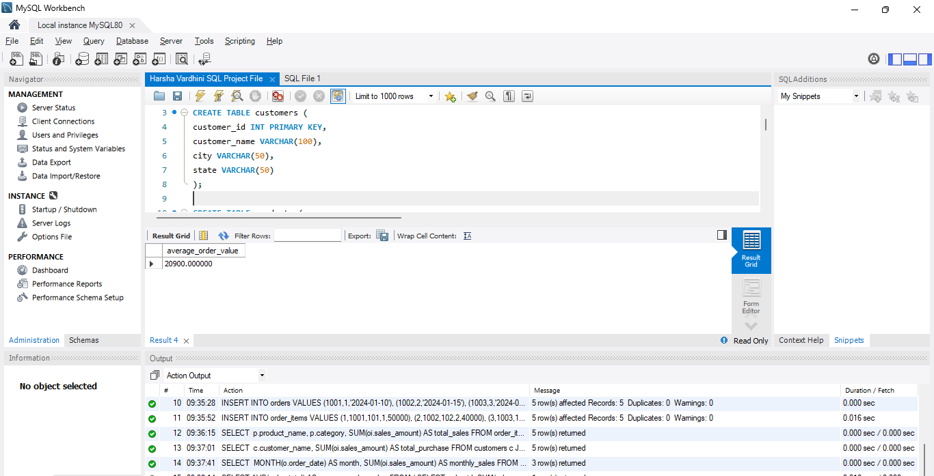
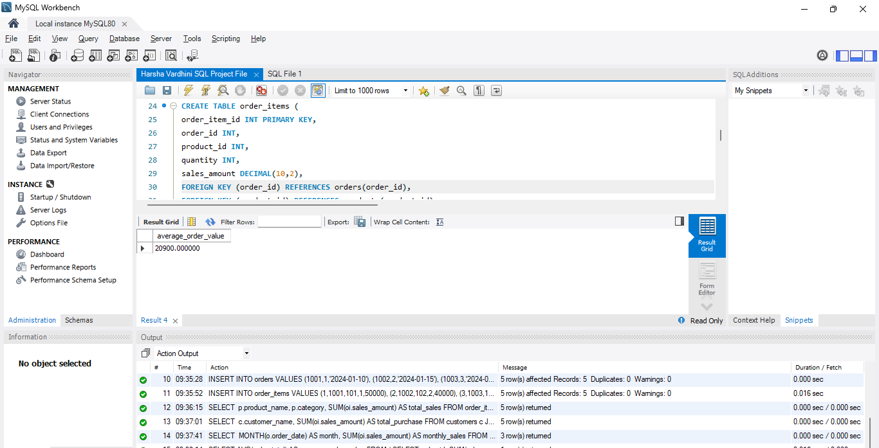
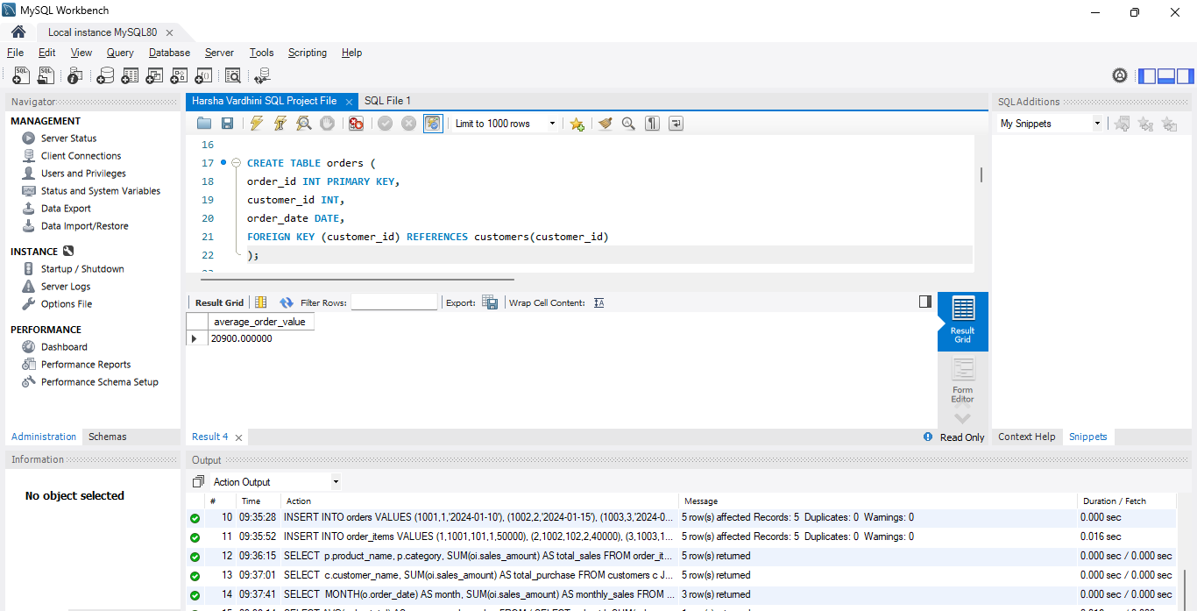
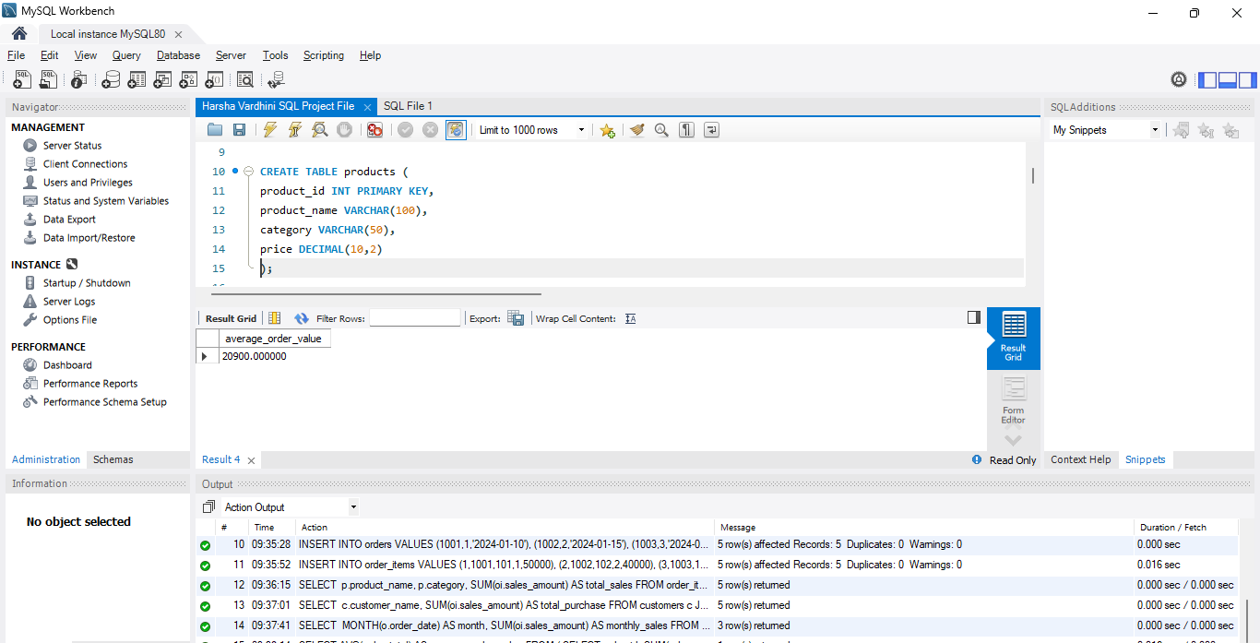


- INSERT statements
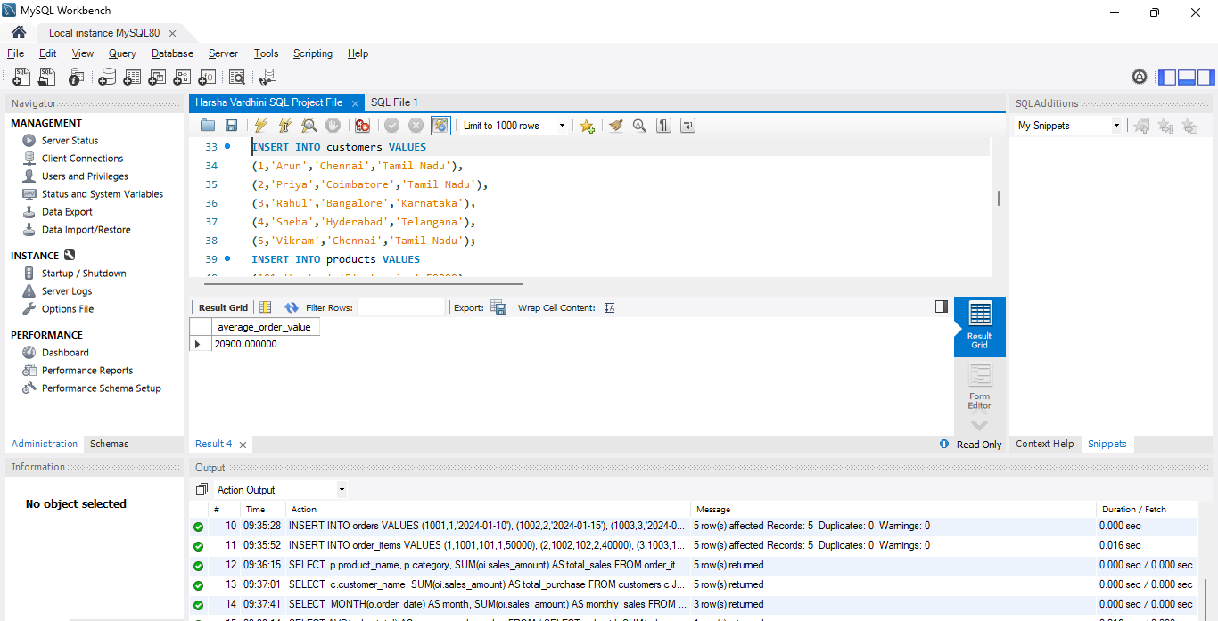
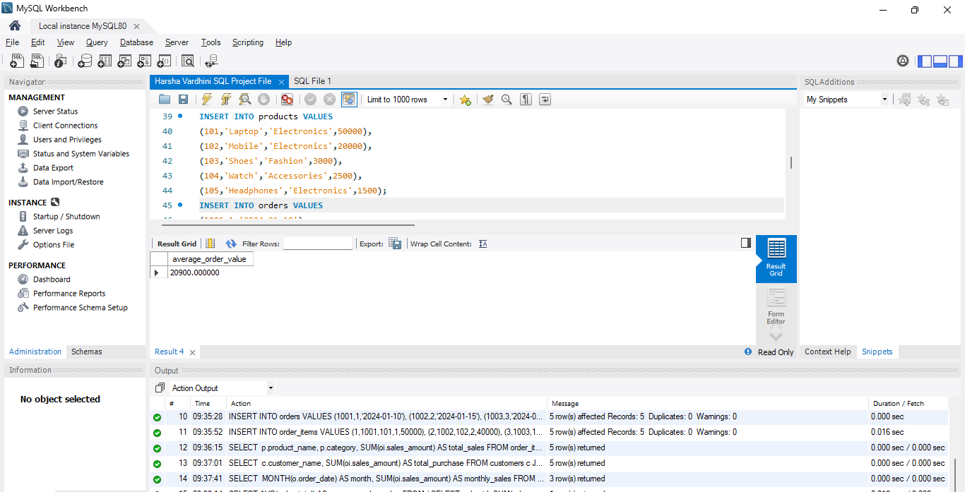
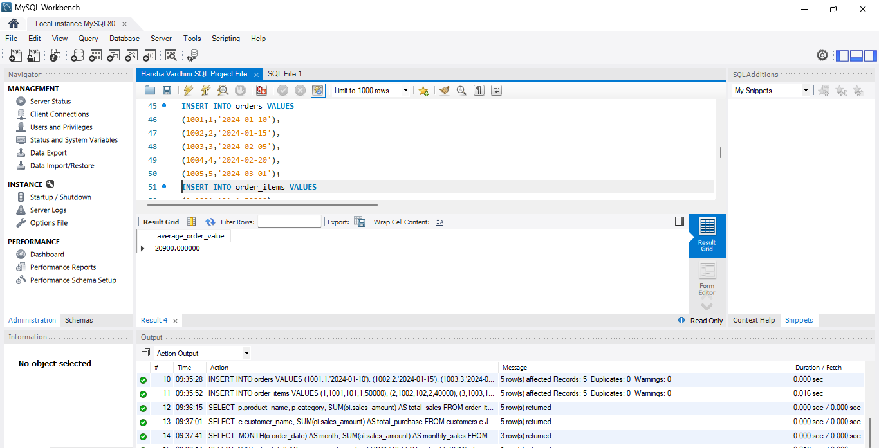
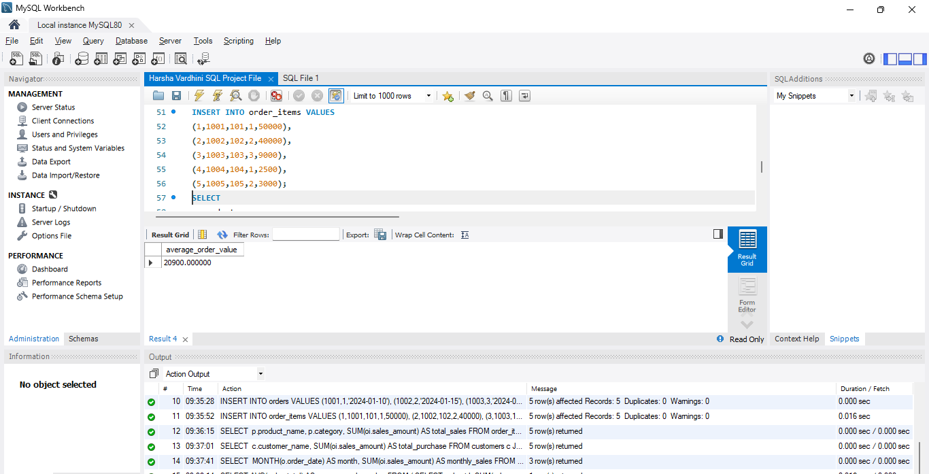

3. Query 1 output (total sales per product)
4. Query 2 output (top customers)
5. Query 3 output (monthly sales)
6. Query 4 output (average order value)
